Signaling Hunter User Manual

January 2010

Chapter 1 Install and Uninstall 3
1.1 Signaling Hunter install 3
1.2 Signaling Hunter uninstall 7
Chapter 2 Instructions for use 8
2.1 Interface Description 8
2.2 Device Group and Device configure 9
2.3 Signaling Tracking 11
2.3.1 CC Tracking 12
2.3.2 Other signaling tracking 15
2.3 Tracking file import 16

Chapter 1 Install and Uninstall
This chapter introduce Signaling Hunter install and uninstall

Signaling Hunter install
Firstly, copy Signaling Hunter setup file to your PC 。
Double-click the installation file：

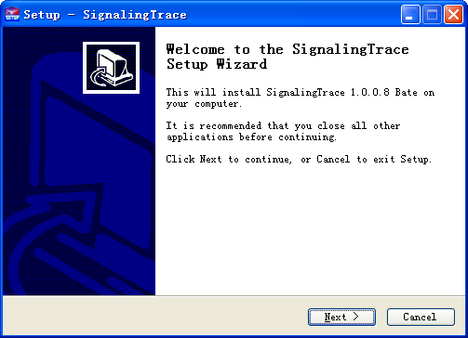

Click ‘Next’, and accept the agreement：
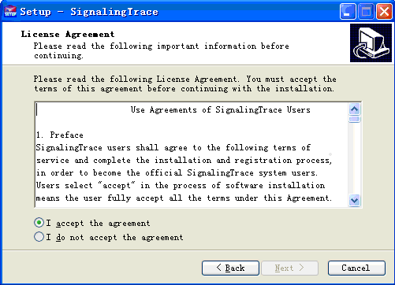

Select the installation path:

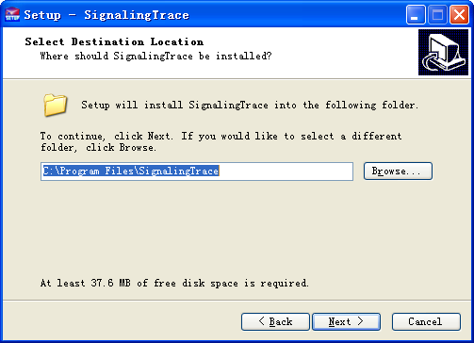

Whether establish the Start menu path:
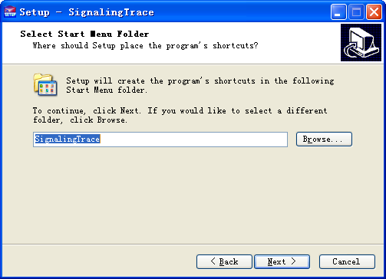

Whether create a shortcut:

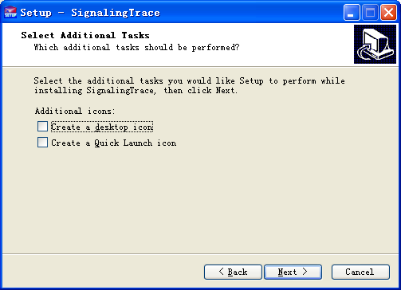

Click install and start install

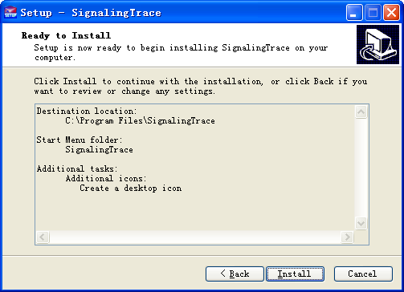
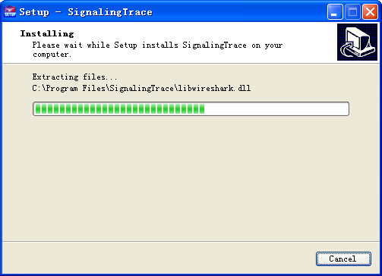

OK, the installation is complete.
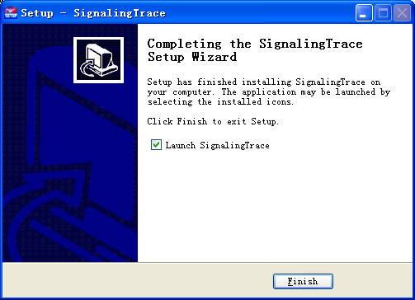
 Notes：
If you can not be used after installation, please contact Allywll customer service!

Signaling Hunter uninstall
Found Unins000.exe file in the installation directory, click Start to uninstall.

Chapter 2 Instructions for use
This chapter describes how to use the Signaling Hunter to tracking signaling message and platform configuration.

2.1 Interface Description
Open Executable file. For the first time to open the following figure, it shows that there is no devices exist:
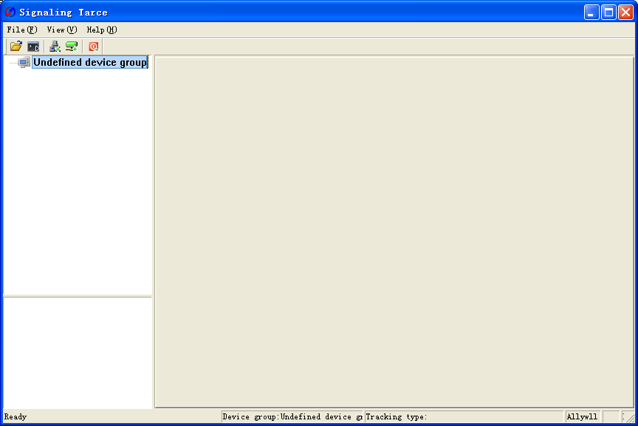
As shown above:
- Block 1: display device group/device/current tracking.
- Block 2: display tracking message.
- Block 3: status bar, display device connecting status and tracking status.
- Block 4: display detail of tracking message.

2.2 Device Group and Device configure
Right button click “Undefined device group”：
Add device Group：Add new device group
Modify Device Group：Modify device group name (Gray is not available)
Delete Device Group：Delete device group (Gray is not available)
Select “Add Device Group”, enter a group name, for example: test
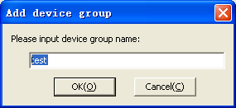
Click ‘OK’, then it will appears like below:

\Right button click test:
Add device Group：Add new device group
Modify Device Group：Modify device group name (Gray is not available)
Delete Device Group：Delete device group (Gray is not available)
Add New Device：add new device under test device group
Select “Add Device Group”, enter a group name, for example: test

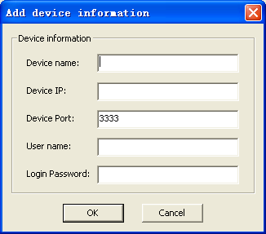

Device IP is device’s IP address, Device Port fixed as 3333, if there are no special circumstances don’t change it, User name and Login Password refer to telnet that device’s username and password(not the web username and password).
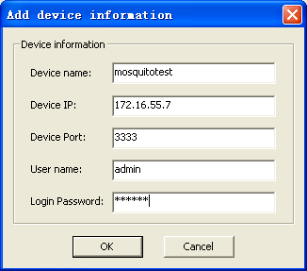
Click ‘OK’, then under test device group, there is a mosquitotest node:
Click Right Button, menu shows below:

2.3 Signaling Tracking
Signaling Hunter can tracking all the signaling as below:
CC(Call Control) --- Allywll proprietary intellectual property rights.
SIP --- standard
MGCP --- standard
H323 --- standard
PRA --- standard
No.7 (SS7 or C7) --- standard
For oversea market, it mainly use SIP、CC、No.7 and PRA, and CC tracking can’t be mixed with other signalings in one tracking tap, because CC tracking is Allywll proprietary intellectual property rights:

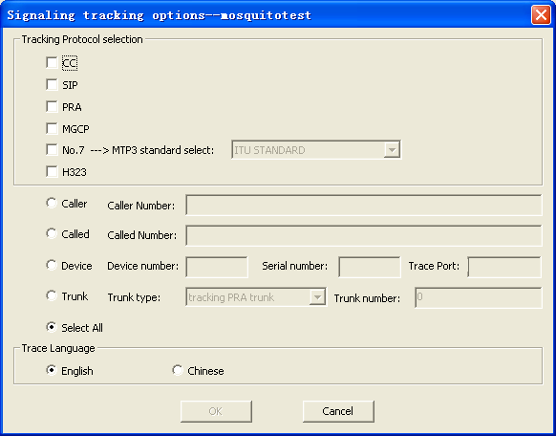
Signaling Tracking can be set by conditions, such as caller number, called number, IAD device number and trunk number, etc. Tracking log can be Chinese and English, default English.
Notes: There can be multi-tracking of a device, except CC tracking, shows below:

2.3.1 CC Tracking
As mentioned earlier, CC tracking can’t be mixed with other signaling tracking in one tracking tap, if you want to tracking other signaling at the same time, please open multi-taps to do it, or via telnet to device and tracking directly.
CC tracking means Call Control tracking, it’s the most commonly used to track，most of the issues are find out by CC tracking.
Click right button, and select Create New Tracking，then it will appears a dialog box, then click CC as below：

Then, setting tracking conditions，like tracking according to called number: 0755877777777：

Then click OK, it will start tracking:

When meet the conditions of call via this device, the tracking information will be displayed in the above interface:

Selected one of an information, all the detailed information will show as below:

In the Detail Information Bar, there are three buttons, namely Save (S), Clear Screen (C), Start / Stop Tracking (S):

Save：Save this tracking message, saved message can be opened by Signaling Hunter.
Clear Screen：Clear Information.
Start/Stop Tracking: You can use this button to control your tracking.

2.3.2 Other signaling tracking
Other tracking including SIP、PRA、MGCP、No.7 and H.323，there are standard. Tracking methods like CC tracking. The difference is that these tracking saved file, which can be opened through the signaling tracking tool, but also can wireshark 1.3 above (inclusive) to open it.
For example, No.7 signaling tracking：
Click right button, then select Create New Tracking, then click No.7, and then select the corresponding MTP3 standard, like below:

Then, setting tracking conditions，like tracking according to called number: 0755877777777：

Then click OK and start tracking:

When meet the conditions of call via this device, the tracking information will be displayed in the above interface:

Selected one of an information, all the detailed information will show as below:

2.3 Tracking file import
In the Signaling Hunter menu ‘File’, then click ‘Open File’：
Then find saved message, select it.

