- Beta Version 71.06.44.02 T6
Models | Software Version | Firmware Name | Building time
MGE1300 | 71.06.44.02 T6 | package_71064402_T6_3000c | 2025-01-21 18:06:47

- Version relevance
  - Base version 71.06.44.02 T5 2024-12-25 19:02:03

- Bug Fixing
  - Support transferred the cause of reason from SIP-T to SS7 when SIP-T with “application/isup”.
- Improvements
Null.
- Others
The following image is device upgraded.
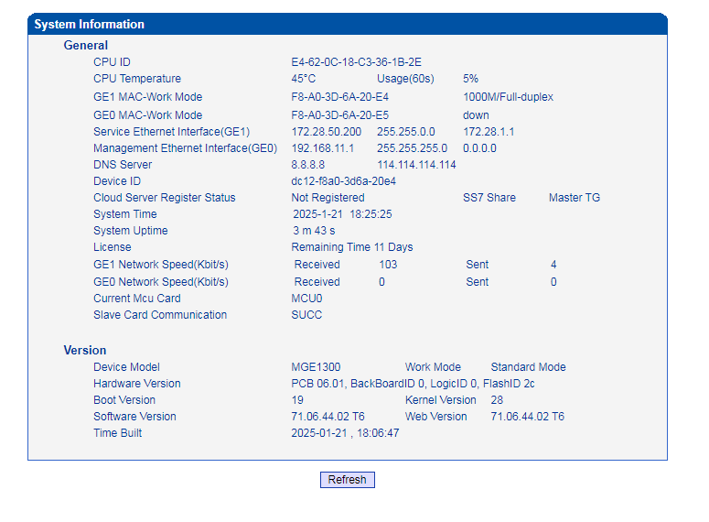

- Note
Null.

