- Beta Version 71.06.44.02 T3
Models | Software Version | Firmware Name | Building time
MGE1300 | 71.06.44.02 T3 | package_71064402_T3_3000c | 2024-08-30 10:12:42

- Version relevance
  - Base version 71.06.44.02 T2 2024-07-22

- Bug Fixing
  - Position 1, SIOS/SIO adjust for Q.781
  - Position 15, the SIP package using big MIME result the SIP-T does not work.

- Improvements
Null.
- Others
The following image is device upgraded.
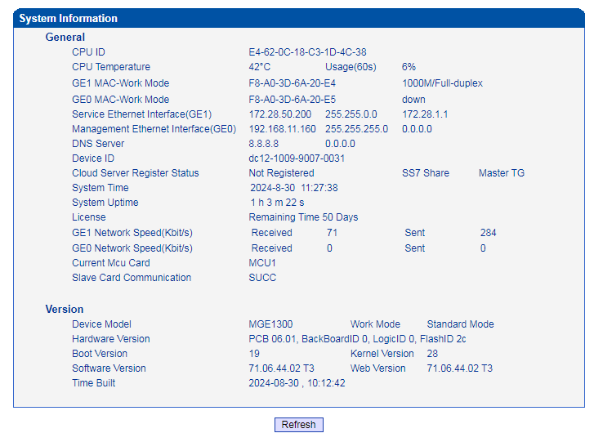

- Note
Null.

