- Beta Version 71.06.43.02 T5
Models | Software Version | Firmware Name | Building time
MGE1200 | 71.06.43.02 T5 | package_71064302_T5_2000c.ldf | 2024-12-25.18:59:59

- Version relevance
  - Base version 71.06.43.02 T4 2024-10-09 10:25:17

- Bug Fixing
  - Transferred the cause of reason from SIP-T to SS7.
  - Fix the bug when using SIP-T for SS7->IP call and re-routing to IP, the 2nd INVITE without ISUP-Body.
- Improvements
Null
- Others
The following image is device upgraded.
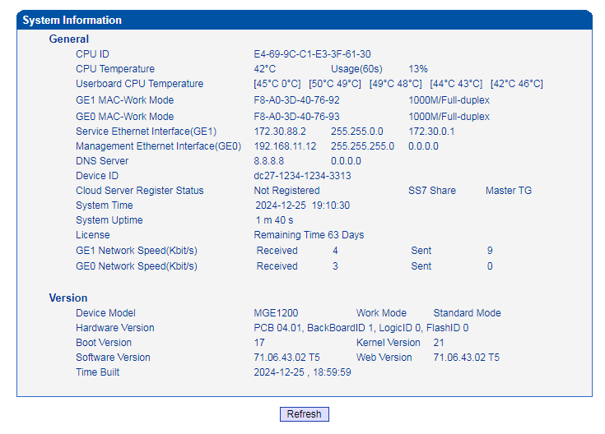
- Note
Null.

