- Beta Version 71.06.43.02 T4
Models | Software Version | Firmware Name | Building time
MGE1200 | 71.06.43.02 T4 | package_71064302_T4_2000c.ldf | 2024-10-09 10:25:17

- Version relevance
  - Base version 71.06.43.02 T3 2024-08-30 10:12:23

- Bug Fixing
  - Position 1, SIOS/SIO adjust for Q.781 more.

- Improvements
Null
- Others
The following image is device upgraded.
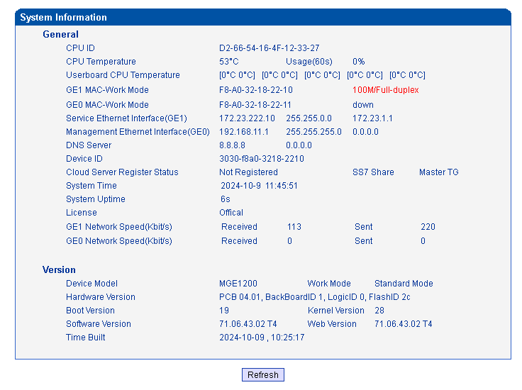
- Note
Null.

