1. **Beta Version 71.06.43.02 T3**

|  |  |  |  |
| --- | --- | --- | --- |
| **Models** | **Software Version** | **Firmware Name** | **Building time** |
| MGE1200 | 71.06.43.02 T3 | package_71064302_T3_2000c.ldf | 2024-08-30 10:12:23 |

1. **Version relevance**
   1. Base version 71.06.43.02 T2 2024-07-22 14:35:03
2. **Bug Fixing**
   1. Position 1, SIOS/SIO adjust for Q.781
   2. Position 15, the SIP package using big MIME result the SIP-T does not work.
3. **Improvements**

Null

1. **Others**

The following image is device upgraded.

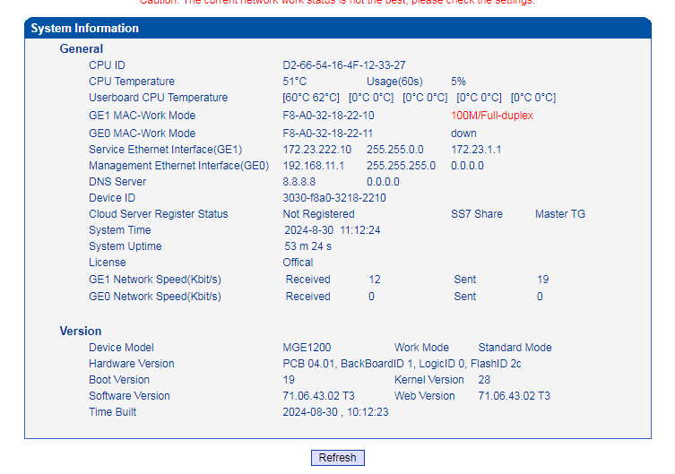

1. **Note**

Null.